MEDIA STATEMENT FOR RELEASE
ISSUED BY THE DRAKENSBERG BOYS CHOIR SCHOOL

THE LIGHT HAS COME AS DRAKENSBERG BOYS CHOIR BRINGS CHRISTMAS MAGIC THIS NOVEMBER
FINAL FOR DISTRIBUTION WITH EMBARGO: 08:00 ON THURSDAY 29 OCTOBER 2026

JOHANNESBURG, SOUTH AFRICA – As the festive season approaches, the world-renowned Drakensberg Boys Choir is preparing to bring the unmistakable sound of Christmas to concert halls and churches across South Africa. Blending traditional carols with the infectious rhythms of African music and contemporary festive favourites, the choir’s much-loved 2026 Noël Tour – The Light has Come promises an uplifting musical experience for audiences of all ages.

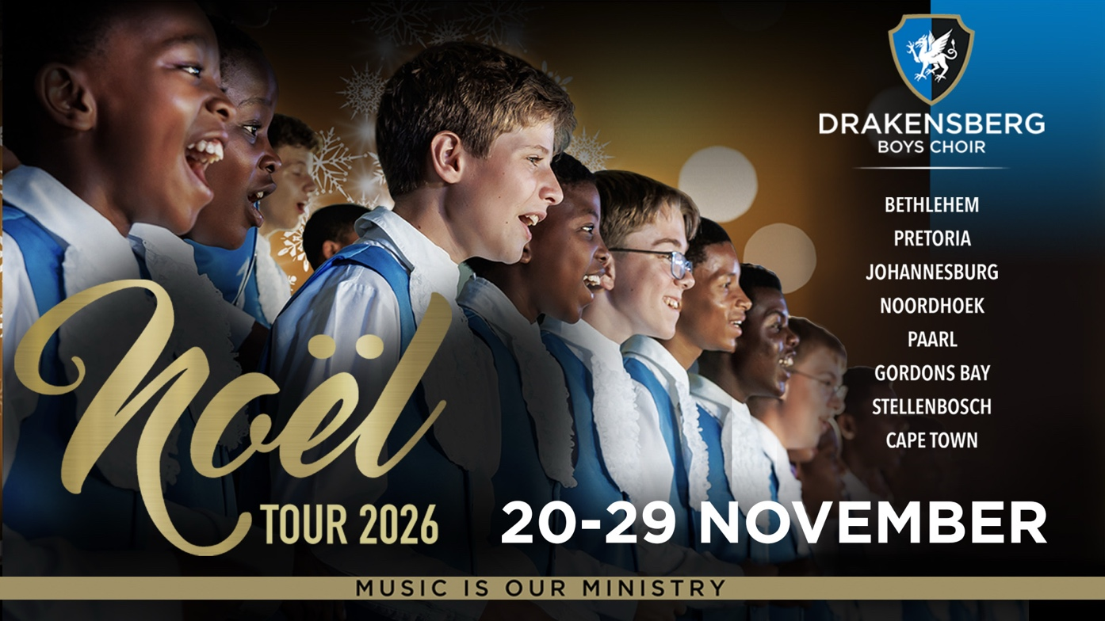

Worldwide, many schools have boys’ choirs, but the Drakensberg Boys Choir is unique and one of only a few of its kind globally: a boarding school that uses choral music as a significant vehicle for holistic education. The mission of the Drakensberg Boys Choir School (DBCS) is to prepare boys for life and leadership through excellence in music, academics, physical development and social enrichment, all within a Christian environment.

"For many families, Christmas is a time to reconnect, reflect and celebrate what matters most," says Hendrik Bekker, Executive Head of the Drakensberg Boys Choir School (DBCS). "That's what makes our Noël Tour so special. It's about much more than beautiful music. It's about creating moments families can share, reminding us of the hope Christmas brings and leaving audiences with a little more joy in their hearts."

Running from 20 to 29 November 2026, the tour will present eight performances across Bethlehem, Pretoria, Johannesburg and the Western Cape. This year's theme, The Light has Come, draws inspiration from the birth of Christ and the enduring message of hope, peace and joy at the heart of Christmas. Building on 2025's The Promise of Light, the programme celebrates the arrival of that light and its power to unite people.

A musical journey from wonder to celebration

“The 2026 Noël programme takes audiences on a two-part musical journey, moving from the mystery and stillness of Christmas to an exuberant celebration of the season,” says Jacques Linde, Head of Choral Activity at Drakensberg Boys Choir School and the choir’s conductor.

Part I – The Mystery of Light explores the wonder of Christ's birth through sacred choral masterpieces and traditional carols. Highlights include Once in Royal David's City, Karl Jenkins' From Our Earth from Stella Natalis, Arvo Pärt's Bogoróditse Djévo, and Jacobus Gallus' O Magnum Mysterium, alongside familiar favourites such as The First Noël, Sussex Carol, and O Holy Night.

Part II – Light becomes Celebration offers a joyful change of pace, combining the vibrant Gloria from Paul Basler's Missa Kenya, the powerful spiritual Ride On, King Jesus! and the distinctly African sounds of An African Christmas and Merrie Krismis. Beloved carols such as Joy to the World and Hark! The Herald Angels Sing sit alongside contemporary favourites, including Little Drummer Boy, Jingle Bells and Mariah Carey's All I Want for Christmas, before the programme concludes with Silent Night.

Linde says the contrast between the two halves makes this year’s programme particularly special. "We want audiences to experience the full emotion of Christmas,” he explains. “There are moments in the first half when the music is so beautiful and still that you can almost feel the room holding its breath. The second half brings the wonderful energy the Drakies are known for, with African rhythms, familiar carols and music that makes you want to celebrate. It’s a programme with something for everyone, but most importantly, it tells a story.” This season, the Drakies will spread Christmas cheer across the Free State and Gauteng before heading to the Western Cape.

The official 2026 Noël Tour schedule is as follows:

Date | Venue | Time | Adults | Pensioners and children
Friday, 20 November | NG Kerk Bethlehem Wes, 48 Kerk Street, Bethlehem – book via www.dbchoir.com | 18:30 | R200 | R180
Saturday, 21 November  10:00 - Johannesburg auditions for prospective Drakies | Special auditions for prospective choristers between 9 and 13 years old to the Drakensberg Boys Choir School at Stone, 54 Melville Road, Illovo, Johannesburg - contact hcato@dbchoir.com to book an audition slot | 11:00 | N/A | N/A
Saturday, 21 November | New Apostolic Church Olympus, Achilles Road, Pretoria – book via www.dbchoir.com | 18:30 | R230 | R200
Sunday, 22 November | Special: The Venue at Melrose Arch, Johannesburg – Magic and Music at Every Corner – book via www.melrosearch.co.za | 18:00 | R350 | R350
Tuesday, 24 November | Cape Point Vineyards, Silvermine Road, Noordhoek, Cape Town – book via www.dbchoir.com | 18:30 | R230 | R200
Wednesday, 25 November | Mistico Equestrian Centre, Lichtenburg Road (R312), Paarl Farms – book via www.dbchoir.com | 18:30 | R230 | R200
Thursday, 26 November | Toringkerk Paarl, corner of Main and Van der Lingen Streets, Paarl – book via www.dbchoir.com | 18:30 | R230 | R200
Friday, 27 November | NG Kerk Gordonsbaai, 87 Beach Road, Gordon's Bay – book via www.dbchoir.com | 18:30 | R230 | R200
Sunday, 29 November | St Saviours, corner of Bowwood and Main Roads, Claremont, Cape Town – book via www.dbchoir.com | 17:00 | R230 | R200

Tickets for the Noël Tour are available via www.dbchoir.com by clicking either the concert bookings button on the home page or the link on the calendar page. To attend the Melrose Arch special performance, audiences must purchase tickets via Computicket. Only 350 tickets are available for the Melrose Arch concert at R350 per person, including children under 12.

A highlight of this year’s Noël Tour is the annual Christmas concert in The Venue at Melrose Arch in Johannesburg on Sunday, 22 November at 18:00. Titled Noël Tour - Magic and Music at Every Corner, the concert forms part of Melrose Arch’s Festive Season celebrations. It continues a cherished tradition, bringing the Drakensberg Boys Choir School’s extraordinary voices to one of Johannesburg’s most popular lifestyle destinations.

“Our longstanding relationship with the Drakensberg Boys Choir School is something we truly value, and welcoming the boys back to Melrose Arch each Christmas is always a highlight of our Festive Season,” says Natalie Stewart, Managing Director of Melrose Arch. “Their music brings a special atmosphere to the precinct, creating moments of joy and togetherness for families and visitors. We look forward to sharing another magical evening with our community. Book early at www.melrosearch.co.za to avoid disappointment. Last year, the Melrose Arch concert tickets sold out very early!”

More than a choir, a celebration of South African talent

The Noël Tour rounds off another memorable year for DBCS, following performances at Music in the Mountains, Music in the City, and its Southern Africa Tour, which took the boys to Botswana, Zambia and Zimbabwe.

Boys aged 9 to 13 can become part of the Drakensberg Boys Choir School! During the tour, boys can audition at Stone, 54 Melville Road, Illovo, Johannesburg, on 21 November 2026 at 11:00 or after each tour concert. Online auditions are also available with the school’s senior music staff. Contact hcato@dbchoir.co.za to book an in-person or online audition slot. See more about the enrolment process at https://dbchoir.com/enrolment.

DBCS is South Africa’s only established choir school, with a strong global reputation built over its 59-year history. Its premium choir brand is internationally respected. The choir has delighted audiences worldwide since 1967, serving as true South African singing ambassadors and bringing a message of hope. Weekly concerts are held on the school campus in the 500-seater auditorium. DBCS continues to fly the South African flag high, locally, regionally and internationally!

Alongside their academic education, the Drakie boys receive world-class musical training while developing the confidence, discipline and character that will serve them throughout their lives. Through its Bursary Fund, DBCS also helps talented boys from diverse backgrounds access these unique educational and musical opportunities, ensuring that the next generation of young South African talent can continue to flourish. Being part of Drakies opens many doors. Many Drakies alumni have excelled not only in the music industry but also as professionals and in sport or business. The calibre of our alumni speaks for itself.

“As we prepare for Christmas, we hope families and friends will take the opportunity to come together, enjoy the music and experience something truly special. If audiences leave feeling inspired, uplifted and reminded of the hope this season represents, we will have achieved what Noël is all about,” Bekker concludes.

FIN
(1331 words)

EDITORS’ NOTES

Media release issued by Stone on behalf of Drakensberg Boys Choir School

Visit the DBCS website to purchase tickets and view the concert programme: http://www.dbchoir.com

For media enquiries, interview requests or in-studio or recorded media appearances, contact:
Kgotso Chauke or Taonga Chiwala of the Drakensberg Boys Choir School media team at Stone
Email: media@stone.consulting
Phone: +27 62 870 2294 / +27 11 447 0168

Alternative media contact and further marketing information or enrolment of boys at the school:
Helga Cato, Marketing Coordinator of Drakensberg Boys Choir School
Email: hcato@dbchoir.com / Phone: +27 83 232 1229
Recruitment link: https://dbchoir.com/enrolment

Contribute to the DBCS bursary fund:
Lizél Potgieter, Accountant of Drakensberg Boys Choir School
Email: accountant@dbchoir.com / Phone: +27 36 468 1012
Donation link: https://dbchoir.com/support-us

Book the Choir for a performance:
Elanza Joubert, Tours and Operations Manager of Drakensberg Boys Choir School
Email: tours@dbchoir.com / Phone: +27 36 468 1012

More helpful website links for media reference:

- Please visit the Drakensberg Boys Choir School website at www.dbchoir.com to learn how Drakensberg Boys Choir School builds character and moulds and develops boys to harness the gift of music to bring hope, impact, and positive change to South Africa and beyond. DBCS offers a unique, complete and diverse schooling experience that will forever change every Drakie boy's life by being part of this centre of excellence. DBCS builds resilience, grows relationships, and fosters global ambassadors with music as the tool for God’s glory.
- Please visit the Drakies Facebook page for views of sold-out performances and Drakie life activity at this unique boys' middle school in the majestic Drakensberg mountains – https://www.facebook.com/dbchoir
- The photo pages on the Drakies website and Facebook page gives a good view of the diversity, life and extraordinary talent of the boys at Drakensberg Boys Choir School – https://dbchoir.com/gallery and https://www.facebook.com/dbchoir/photos
- Visit these video links for a glimpse of the world-renowned Choir's international and local choral work, both in the classical and distinctly African genres: https://www.dbchoir.com/gallery (scroll down on the page for videos), https://www.youtube.com/user/DBCHOIR, https://youtu.be/C521O4XHO_I, and https://www.facebook.com/dbchoir/videos/934329527988775/

